Project Documentation

INSIGHT STREAM

## Project Title: INSIGHT STREAM

**Team ID: NM2025TMID47885**

**Team Leader:** S.Gowtham & mr.gowtham1111@gmail.com

## Team Members:

* + M.Gnanagiri & gnnagiri@gmail.com
  + C.Giridharan & [giritharan9842@gmail.com](mailto:giritharan9842@gmail.com)
  + R.Hariharashudhan & hariharashudhanrs29@gmail.com

# Introduction

# Welcome to the cutting-edge frontier of news exploration with InsightStream! Our innovative web application is meticulously crafted to transcend the boundaries of traditional news consumption, catering to the diverse interests of both avid news enthusiasts and seasoned information professionals. With a focus on an intuitive user interface and a robust feature set, InsightStream is poised to redefine the entire news discovery and consumption process.

# ​Crafted with a commitment to user-friendly aesthetics, InsightStream immerses users in an unparalleled journalistic adventure. You can effortlessly navigate through a wide array of news categories with features like dynamic search, bringing you the latest and most relevant stories from around the world.

# ​From those seeking the latest headlines to seasoned news connoisseurs, InsightStream embraces a diverse audience, fostering a dynamic community united by a shared passion for staying informed. Our vision is to reshape how users interact with news, presenting a platform that not only delivers breaking stories but also encourages collaboration and sharing within the vibrant news community.

# ​Embark on this informative journey with us, where innovation seamlessly intertwines with journalistic tradition. Every click within InsightStream propels you closer to a realm of global happenings and perspectives. Join us and experience the evolution of news consumption, where each feature is meticulously crafted to offer a glimpse into the future of staying informed.

# ​Elevate your news exploration with InsightStream, where every headline becomes a gateway to a world of information waiting to be discovered and understood. Trust InsightStream to be your reliable companion on the journey of staying connected with the pulse of the world.

# Project Overview

* **Purpose: Insight Stream helps users navigate the news landscape by providing curated, real-time insights, personalized streams, and simplified access to trustworthy information across diverse topics.**

## Features: News from API Sources: The application provides a wide-ranging library of global news across various categories and interests, ensuring comprehensive coverage of current events.

## Visual News Exploration: Users can discover breaking stories and explore different news categories through curated image galleries.

## Intuitive Design: The application has a clean and modern interface designed for optimal user experience and clarity in information presentation.

## Advanced Search Feature: Users can easily find news articles on specific topics using a powerful search feature, which provides tailored news content based on their interests.

1. Architecture

* **Frontend:** The user interface is built using **React.js**. It leverages **Bootstrap** and **Material UI** for a responsive and modern design. The frontend is responsible for fetching and displaying news articles, user profiles, and chat interfaces.
* ​**Backend:** The server-side logic is handled by **Node.js** and **Express.js**. The backend manages user authentication, API endpoints for fetching news, managing user-specific projects, processing applications to projects, and handling real-time chat messages.
* ​**Database:** **MongoDB**: The mongoDB is not applicable to this application

# Setup Instructions

**Prerequisites:**

* + - Node.js: The JavaScript runtime environment for the backend.
    - Git: A version control system to clone the repository.
    - React.js: The frontend framework.
    - Visual Studio Code: A popular code editor for development.

## Installation Steps:

Git and Node.js Commands

To manage a project, you'll first get the code, then install the required tools, and finally run the application.

1. Get the Code

* New Project: Use git clone <repository_url> to download the project.

* Existing Project: Use git pull to update your local copy with the latest changes from the repository.

2. Install Tools

* Run npm install in the project directory. This command reads the package.json file and downloads all the necessary dependencies.

3. Run the Application

* Use npm start to run the web application on your local machine. It executes the start script defined in package.json, making the app accessible in your browser, usually at a localhost address.

# Folder Structure

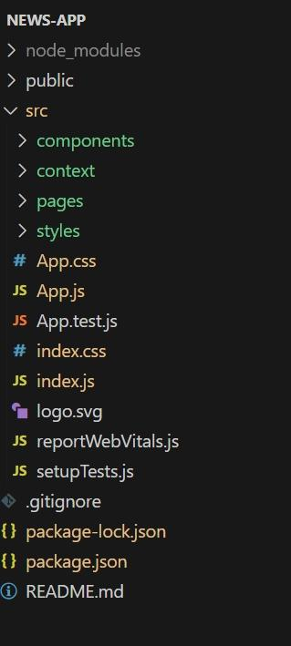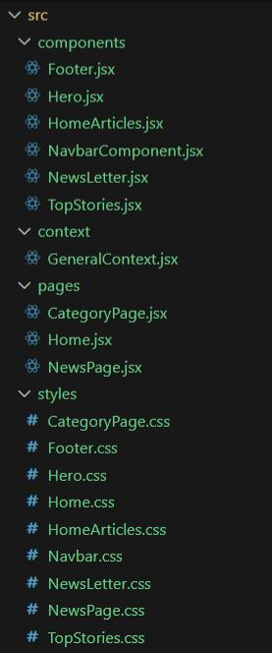

# Running the Application

## 

Open the terminal in the code folder the run the command npm start to host the application in the local host it will be available in the localhost

* + **Access:** Visit [http://localhost:3000](http://localhost:3000/)

# API Documentation

NewsAPI Integration 📰

This app uses the NewsAPI.org to fetch news headlines and popular stories.

Top Headlines

To get top headlines, the app makes a request to the following endpoint:

Endpoint: https://newsapi.org/v2/top-headlines

Parameters:

* country: The country code (e.g., us for the United States).

* category: The news category, specifically business.

* apiKey: Your unique API key.

Example:

https://newsapi.org/v2/top-headlines?country=us&category=business&apiKey=YOUR_API_KEY

Popular Stories

For popular stories, the app uses the everything endpoint, sorting the results by popularity.

Endpoint: https://newsapi.org/v2/everything

Parameters:

* q: The search keyword, typically business.

* sortBy: Set to popularity to get popular articles.

* apiKey: Your unique API key.

Example:

https://newsapi.org/v2/everything?q=business&sortBy=popularity&apiKey=YOUR_API_KEY

Response

The API returns a JSON object containing an array of articles. Each article includes details such as its title, description, and url.

If you need more details on other available parameters, you can check the official NewsAPI documentation

# User Interface

* + Landing Page
  + 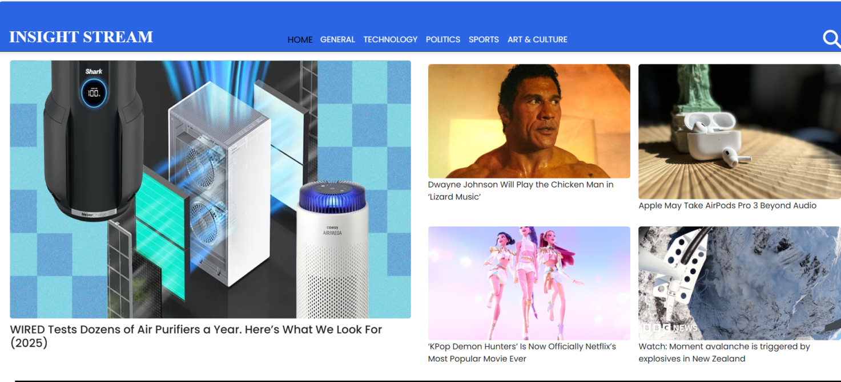
  + Category page
  + 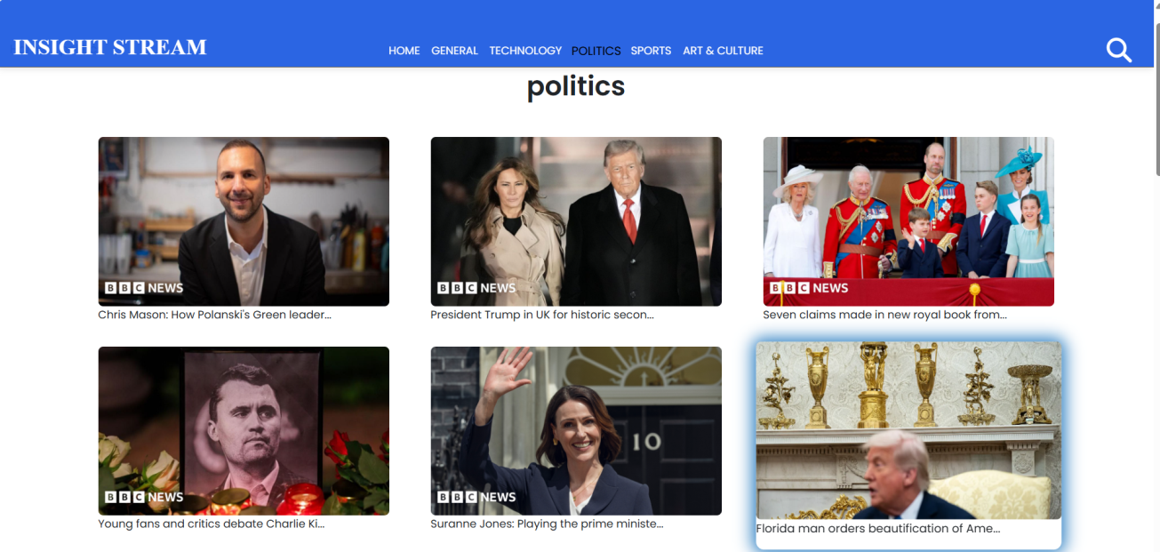
  + Footer
  + 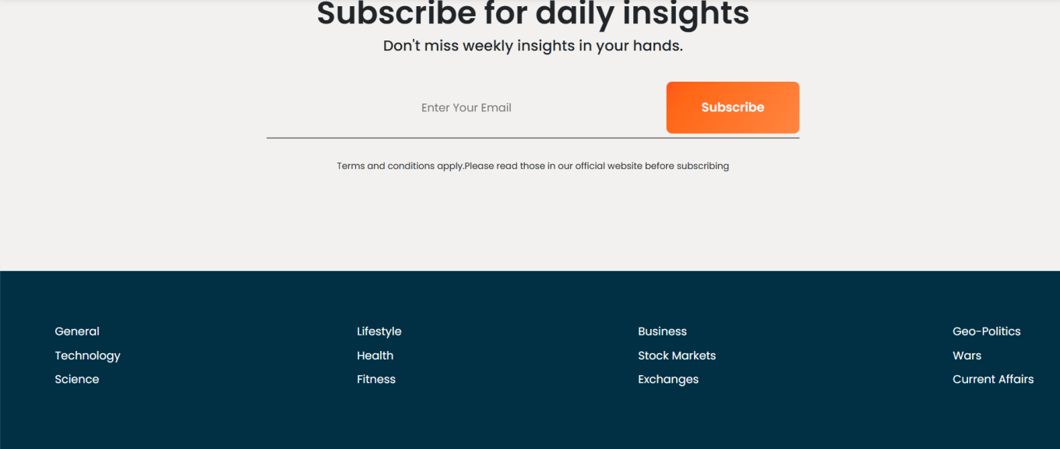
  + Article page & Top stories
  + 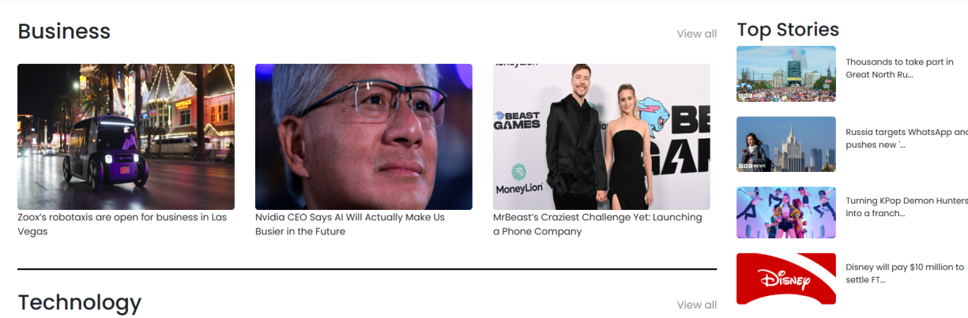

# Screenshots or Demo

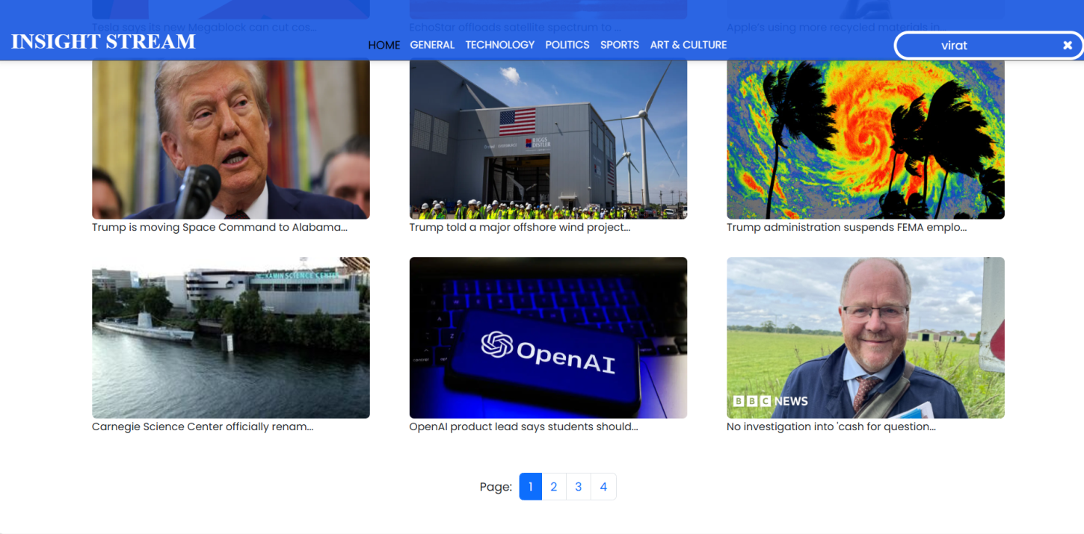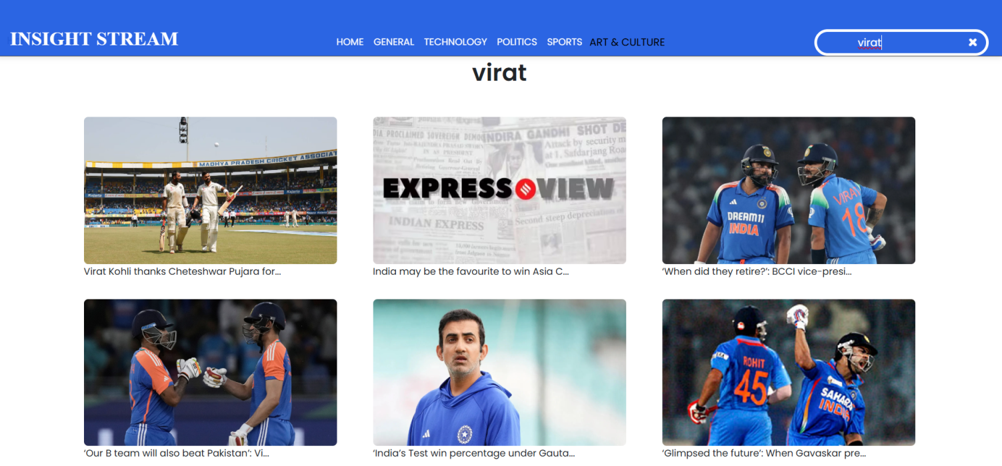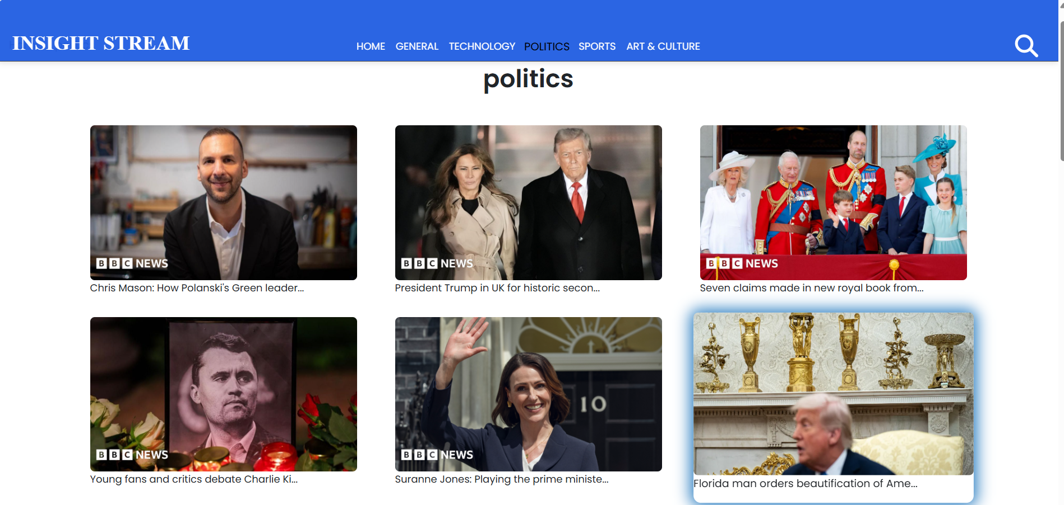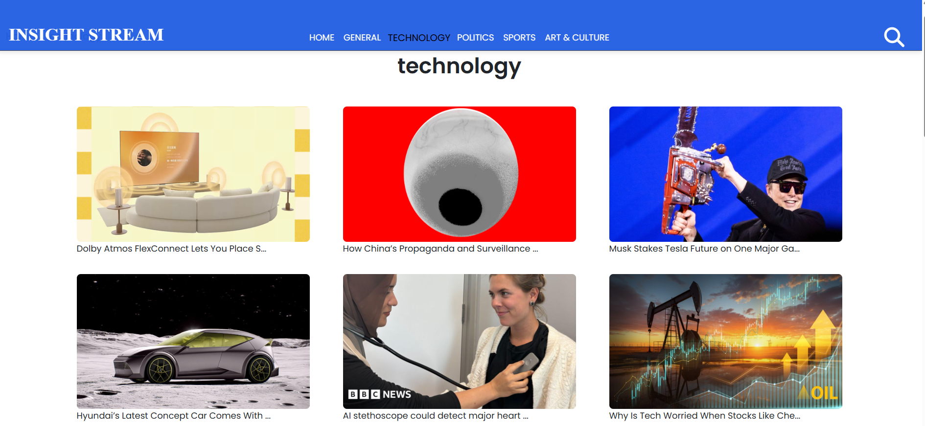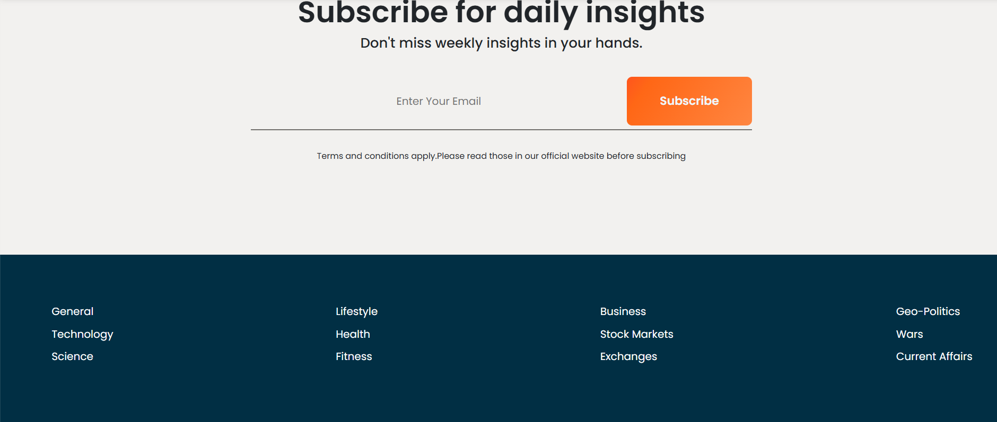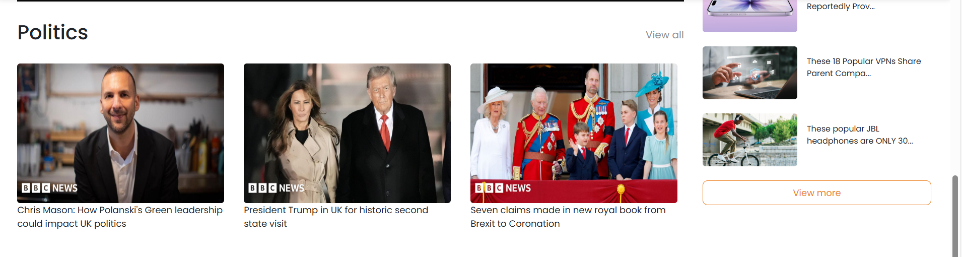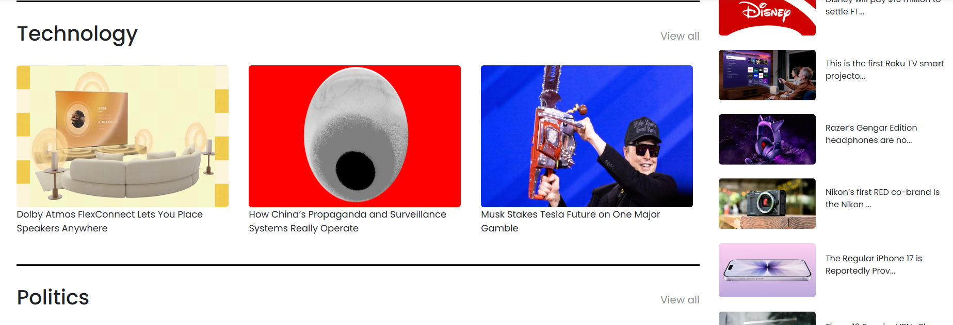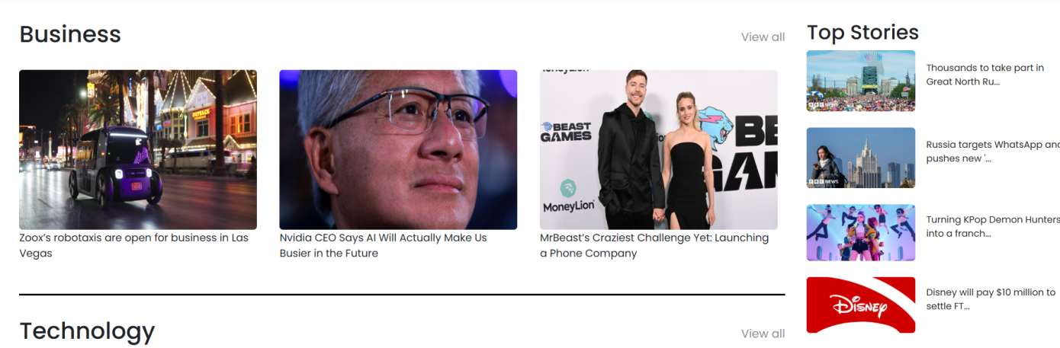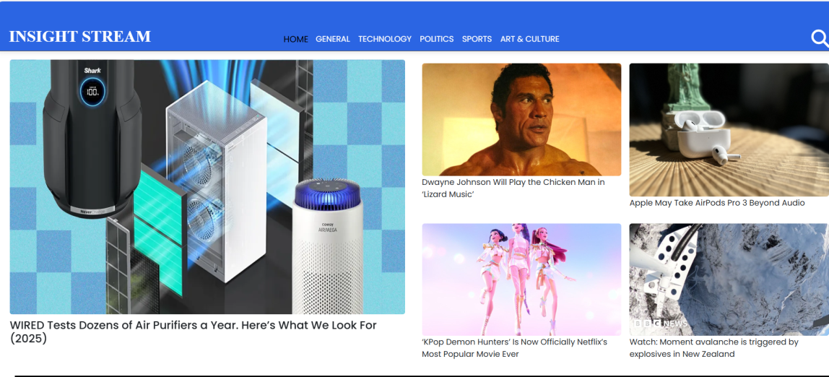

1. **Known Issues**

* Unable to authenticate the news letter subscription feauture
* Unable to store subscribers date permenently

1. **Future Enhancements**

Future Enhancements for Web App

This section outlines professional, actionable plans for enhancing the web application. Each feature is designed to improve user experience, increase engagement, and provide new opportunities for growth.

1. User Authentication and Personalization

* Authentication: Implement a robust user authentication system. This will enable user accounts, allowing for personalized experiences and secure access to content. Consider using third-party login services (e.g., Google Sign-In) to make the sign-up process quick and easy for users. This will be the foundation for all other personalization features.

* Relevant Content: Once users are authenticated, their interactions can be tracked to provide a personalized content feed. The system will analyze user behavior (e.g., articles read, topics liked) to offer dynamic content and recommendations that are highly relevant to their interests.

2. Dynamic Search and Filtering

* Real-time Search: Upgrade the search functionality to provide a dynamic, real-time experience. As a user types, search results should update instantly, showing relevant articles and keywords. This is often done by listening for input events and filtering content on the client side, or making quick API calls to a search service.

* Advanced Filters: Add an advanced filtering system that allows users to narrow down search results by various criteria like category, source, date, or keywords. This empowers users to find exactly what they're looking for with greater precision.

3. Subscription Plans and Monetization

* Tiered Subscriptions: Introduce a tiered subscription model to provide enhanced features and a better experience for paying users. A common structure includes:

* Free Tier: Access to basic app functionality and a limited number of articles per month.

* Premium Tier: Unlimited access to all content, an ad-free experience, and early access to new features.

* Personalized Tier: This top-level plan could include exclusive content, advanced personalization options, or one-on-one sessions, depending on the app's niche.

* Payment Integration: Implement a secure payment gateway (e.g., Stripe, PayPal) to handle recurring billing and manage subscriptions smoothly.

4. Multiple User Themes

* User-Selected Themes: Allow users to choose between a light and a dark theme. This simple but impactful feature improves usability and reduces eye strain for users who prefer a different color scheme, especially during night-time use.

* Customization Options: In the future, this can be expanded to include other themes or allow users to customize colors and fonts, offering a deeper level of personalization.